Basic PHP Syntax
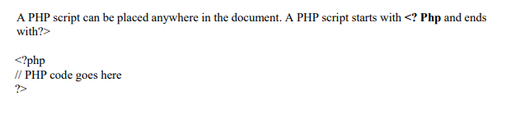

Creating (Declaring) PHP Variables
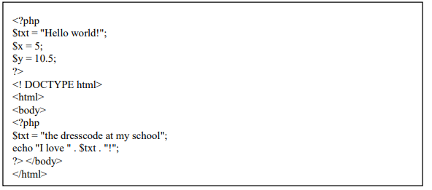

The PHP echo Statement
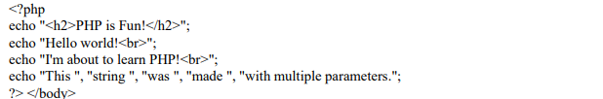

PHP String
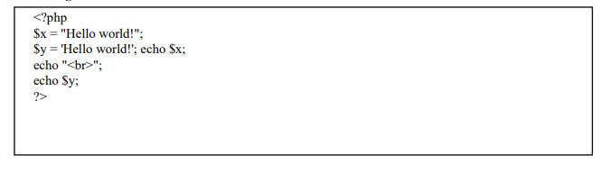

PHP Conditional Statements
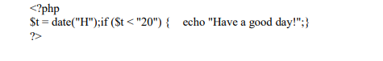

The PHP switch Statement
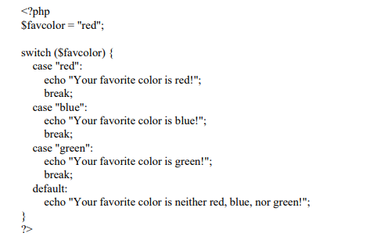

The PHP for Loop
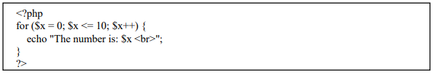

The PHP foreach Loop
